Student Performance Data Visualization Report

- INTRODUCTION:- This report present the visualization created using the Student Performance Dataset. The objective is to understand the data through charts and identify useful insights.

- DASHBOARD:-

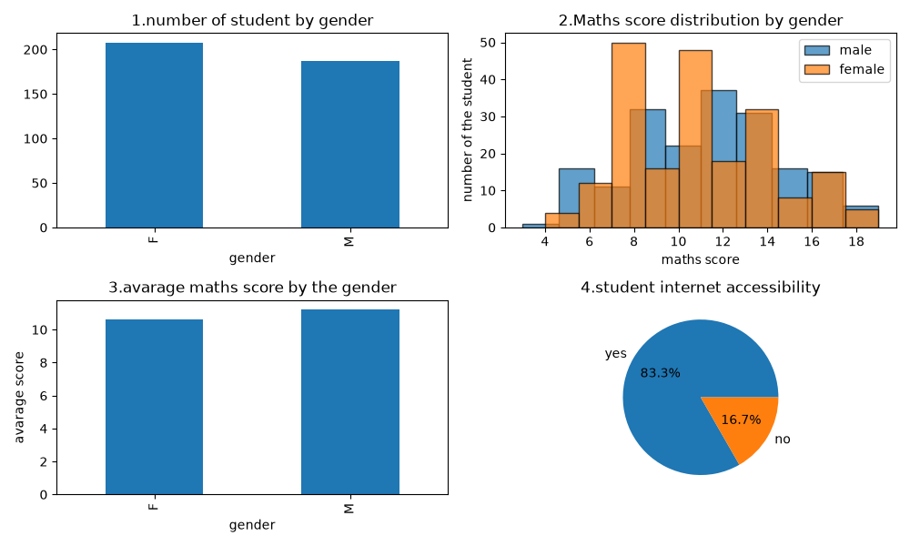

- As you can see the first chart Number Of Student By Gender this shows that number of Females are more than the Males students.
- Females are :-200 students
- Males are :- 180 students (approx.)

- As you can see in the second chart it shows the Maths Score Distribution By The Gender . In this female scores more marks then the male student.
- Male students:- 39 (approx.)
- Female students:- 49 (approx.)

- As you can see the third chart Average Maths Scores By Gender this shows that male students scored more average marks in the maths.
- Highest average scores scored by the Males.

- As you can see in the fourth chart Students Internet Accessibility this shows how many students(in percentage) use the internet.
- Uses internet : 83.3%
- Not use internet : 16.7%

- Conclusion:
The visualization helps us to understand the student performance by showing the score distribution, gender distribution, average scores, and internet accessibility. These insights make the data easier to analyze and interpet.

